Yifu He

Q1:

Firstly,

Draw the picture of the MACD and singal_line:

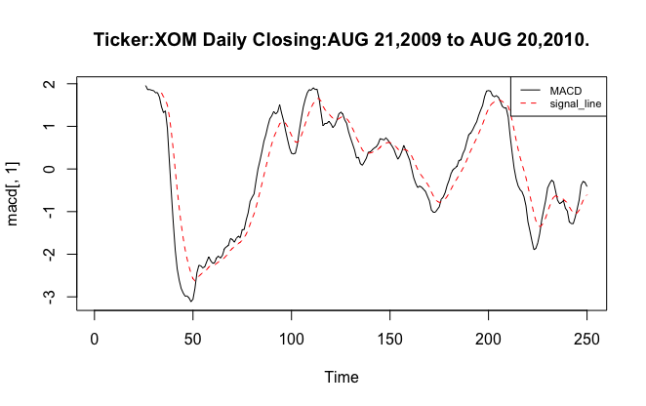

Then, find the signal and calculate its return.

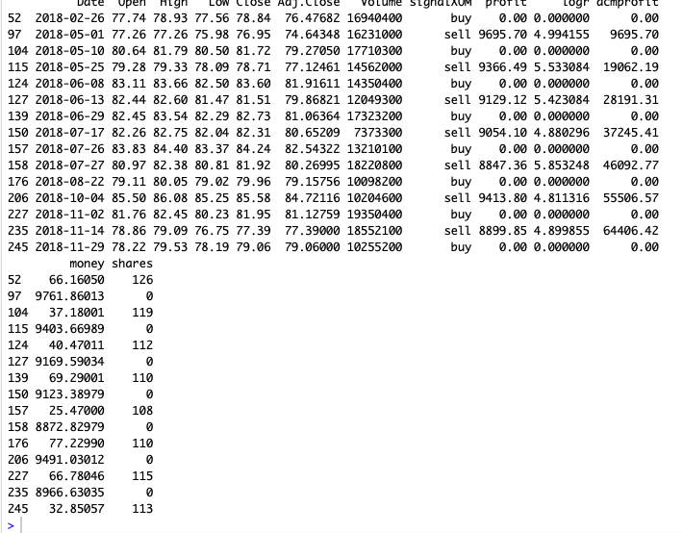

Q2:

Calculate its sharpe ratio:



Q3:

7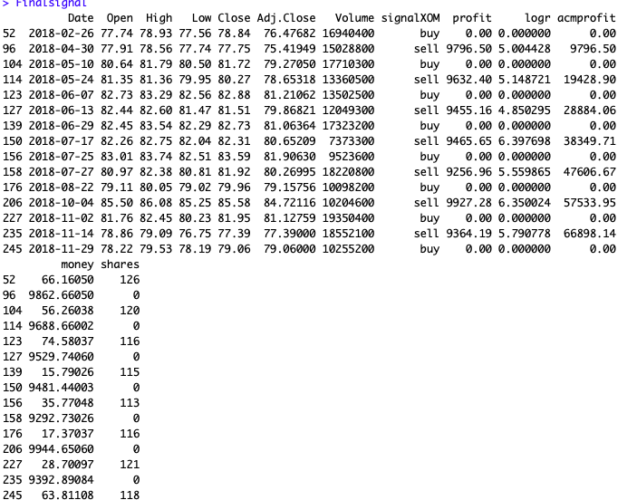



w## install the package of MACD

install.packages("quantmod")

install.packages("PerformanceAnalytics")

install.packages("xts")

install.packages("zoo")

install.packages("TTR")

require("TTR")

require("xts")

require("zoo")

require("quantmod")

require("PerformanceAnalytics")

## read the file

getwd()

setwd("/Users/yifuhe/Desktop")

File <-read.csv("XOM-1.csv")

###----------------------------------------- Question1

XOMclose <-unlist(File[6])

##get the plot of MACD

macd <-MACD(XOMclose,nFast=12,nSlow=26,nSig=9,maType="EMA",percent=TRUE)

macd

ts.plot(macd[,1],main="Ticker:XOM Daily Closing:AUG 21,2009 to AUG 20,2010.")

lines(macd[,2],col="red",lty=2)

legend("topright",c("MACD","signal_line"),col=c(1,2),lty=c(1,2),cex=0.7)

cal <- c(rep(0,33))

for (i in 34 : nrow(macd))

{

if (macd[i,1] > macd[i,2]){cal[i] <- 1}

else {cal[i] <- -1}

}

cal

signalXOM <- rep(0,250)

for(i in 34 : nrow(macd)) {

if ((cal[i] - cal[i - 1]) == 2) {signalXOM[i] <- 'buy'}

else if((cal[i] - cal[i - 1]) == -2) {signalXOM[i] <- 'sell'}

}

XOM <-cbind(File,signalXOM)

Finalsignal <- subset(XOM, signalXOM != 0)

Finalsignal

nrow(Finalsignal)

##

profit <-rep(0,15)

acmprofit<-rep(0,15)

logr <-rep(0,15)

shares <-rep(0,15)

money <-rep(0,15)

shares[1]=10000%/%Finalsignal[1,5]

money[1]=10000-(shares[1]*Finalsignal[1,5])

shares

money

for (i in 1:15){

if((i %% 2) ==1 & (i>2)){

shares[i]=(money[i-1]) %/% (Finalsignal[i,5])

money[i]=money[i-1]-Finalsignal[i,5]*shares[i]

}

else if((i %% 2)==0){

shares[i]=0

money[i]=money[i-1]+shares[i-1]*Finalsignal[i,5]

logr[i]=log(money[i])-log(money[i-1])

profit[i]=money[i]-money[i-1]

total=0

for(j in 1:i){

total=total+profit[j]

}

acmprofit[i]=total

}

}

Finalsignal <-cbind(Finalsignal,profit)

Finalsignal<-cbind(Finalsignal,logr)

Finalsignal<-cbind(Finalsignal, acmprofit)

Finalsignal <-cbind(Finalsignal,money)

Finalsignal <-cbind(Finalsignal,shares)

Finalsignal

###----------------------------------------Question 2

calcu <- subset(Finalsignal, logr != 0)

calcu

ri<- mean(calcu[,10])

std<-sd(calcu[,10])

sharp <- (ri-0.0511)/std

sharp

###_______________-question3

macd <-MACD(XOMclose,nFast=12,nSlow=26,nSig=7,maType="EMA",percent=TRUE)

macd

ts.plot(macd[,1],main="Ticker:XOM Daily Closing:AUG 21,2009 to AUG 20,2010.")

lines(macd[,2],col="red",lty=2)

legend("topright",c("MACD","signal_line"),col=c(1,2),lty=c(1,2),cex=0.7)

cal <- c(rep(0,31))

for (i in 32 : nrow(macd))

{

if (macd[i,1] > macd[i,2]){cal[i] <- 1}

else {cal[i] <- -1}

}

cal

signalXOM <- rep(0,250)

for(i in 32 : nrow(macd)) {

if ((cal[i] - cal[i - 1]) == 2) {signalXOM[i] <- 'buy'}

else if((cal[i] - cal[i - 1]) == -2) {signalXOM[i] <- 'sell'}

}

XOM <-cbind(File,signalXOM)

Finalsignal <- subset(XOM, signalXOM != 0)

Finalsignal

nrow(Finalsignal)

##

profit <-rep(0,15)

acmprofit<-rep(0,15)

logr <-rep(0,15)

shares <-rep(0,15)

money <-rep(0,15)

shares[1]=10000%/%Finalsignal[1,5]

money[1]=10000-(shares[1]*Finalsignal[1,5])

shares

money

for (i in 1:15){

if((i %% 2) ==1 & (i>2)){

shares[i]=(money[i-1]) %/% (Finalsignal[i,5])

money[i]=money[i-1]-Finalsignal[i,5]*shares[i]

}

else if((i %% 2)==0){

shares[i]=0

money[i]=money[i-1]+shares[i-1]*Finalsignal[i,5]

logr[i]=log(money[i])-log(money[i-1])

profit[i]=money[i]-money[i-1]

total=0

for(j in 1:i){

total=total+profit[j]

}

acmprofit[i]=total

}

}

Finalsignal <-cbind(Finalsignal,profit)

Finalsignal<-cbind(Finalsignal,logr)

Finalsignal<-cbind(Finalsignal, acmprofit)

Finalsignal <-cbind(Finalsignal,money)

Finalsignal <-cbind(Finalsignal,shares)

Finalsignal

###----------------------------------------Question 2

calcu <- subset(Finalsignal, logr != 0)

calcu

ri<- mean(calcu[,10])

std<-sd(calcu[,10])

sharp <- (ri-0.0511)/std

sharp

###_________________________

macd <-MACD(XOMclose,nFast=12,nSlow=26,nSig=11,maType="EMA",percent=TRUE)

macd

ts.plot(macd[,1],main="Ticker:XOM Daily Closing:AUG 21,2009 to AUG 20,2010.")

lines(macd[,2],col="red",lty=2)

legend("topright",c("MACD","signal_line"),col=c(1,2),lty=c(1,2),cex=0.7)

cal <- c(rep(0,35))

for (i in 36 : nrow(macd))

{

if (macd[i,1] > macd[i,2]){cal[i] <- 1}

else {cal[i] <- -1}

}

cal

signalXOM <- rep(0,250)

for(i in 36 : nrow(macd)) {

if ((cal[i] - cal[i - 1]) == 2) {signalXOM[i] <- 'buy'}

else if((cal[i] - cal[i - 1]) == -2) {signalXOM[i] <- 'sell'}

}

XOM <-cbind(File,signalXOM)

Finalsignal <- subset(XOM, signalXOM != 0)

Finalsignal

nrow(Finalsignal)

##

profit <-rep(0,15)

acmprofit<-rep(0,15)

logr <-rep(0,15)

shares <-rep(0,15)

money <-rep(0,15)

shares[1]=10000%/%Finalsignal[1,5]

money[1]=10000-(shares[1]*Finalsignal[1,5])

shares

money

for (i in 1:15){

if((i %% 2) ==1 & (i>2)){

shares[i]=(money[i-1]) %/% (Finalsignal[i,5])

money[i]=money[i-1]-Finalsignal[i,5]*shares[i]

}

else if((i %% 2)==0){

shares[i]=0

money[i]=money[i-1]+shares[i-1]*Finalsignal[i,5]

logr[i]=log(money[i])-log(money[i-1])

profit[i]=money[i]-money[i-1]

total=0

for(j in 1:i){

total=total+profit[j]

}

acmprofit[i]=total

}

}

Finalsignal <-cbind(Finalsignal,profit)

Finalsignal<-cbind(Finalsignal,logr)

Finalsignal<-cbind(Finalsignal, acmprofit)

Finalsignal <-cbind(Finalsignal,money)

Finalsignal <-cbind(Finalsignal,shares)

Finalsignal

###----------------------------------------Question 2

calcu <- subset(Finalsignal, logr != 0)

calcu

ri<- mean(calcu[,10])

std<-sd(calcu[,10])

sharp <- (ri-0.0511)/std

sharp